Bridges Project Service Summary

Education and Employability Team

Education and Employability Coordinator Age 12 – 21 East Lothian
- Manages the Education and Employability team, overseeing day to day operation
- Allocates referrals in to the team and works in partnership with a variety of external colleagues
- Delivers an effective employability casework service to young people
- Support to progress in to opportunities such as employment, further education and training
- Referrals to this service can be made at any time

Employability Support Worker (Schools), Way2Work S4 East Lothian
- Yearlong employability skills programmes for young people in S4 at 6 high schools in East Lothian
- Provides tailored support packages for young people enabling them to create and realise their career pathways
- Support to progress in to post school opportunities
- Referrals are made once per year by schools. We do not accept rolling referrals.

GIRFEC Support Worker, Inclusion Support Service S2 – S6 East Lothian
- Provides bespoke, individually tailored support packages to young people not engaging with mainstream school
- One to one intervention and group learning opportunities
- Emotional wellbeing support
- Practical support to enable young people to progress in to meaningful and sustainable destinations
- We do not accept direct referrals for this service

Employability Support Worker 16+, Spark Your Future Age 16 - 24 East Lothian
- Effective casework and group work service for young people facing a combination of barriers
- Supports young people to gain employability skills, life skills and progress to meaningful opportunities
- Provides vocational and industry specific accreditation and training
- Support to gain confidence and skills required to gain employment, apprenticeships and further education
- Referrals to this service can be made at any time

Educational Support Worker, Support2Thrive Age 13 - 18 East Lothian and Midlothian
- An effective casework and group work service for young people facing a combination of barriers
- Supports young people to gain employability skills, life skills and progress to meaningful opportunities
- Provides vocational and industry specific accreditation and training
- Support to gain confidence and skills required to gain employment, apprenticeships and further education
- Referrals to this service can be made at any time

Skills for Life Team

Mental Health and Wellbeing
Personal Development Worker Age 12 – 18 East Lothian and Midlothian
- Emotional and practical solution focused support
- Support to improve mental health and deal with challenges such as stress and anxiety
- Provides a casework service which helps young people manage the transition to adult responsibilities
- Support to build confidence, improve self-esteem, increase resilience and develop coping strategies
- Full capacity, closed for referrals

Support Worker (Young Carers) Age 15 – 25 East Lothian
- Provides bespoke, individually tailored support packages to young carers and young adult carers
- Practical and emotional support to effectively manage the dual roles of being a student and a carer
- Support to maintain good health and wellbeing and increase confidence with caring role
- Referrals to this service can be made at any time

Independent Living

Independent Living Support Workers, Homemaker Service Age 15 – 25 East Lothian
- Customised one to one support to young tenants and prospective young tenants
- Support to develop independent living skills such as cooking and budgeting
- Support to secure, maintain and sustain tenancies
- Support to navigate housing options and process
- Referrals to this service can be made at any time

Group Support Worker Age 12 – 18 East Lothian
- Provides a group work programme of sessions and workshops which develop life skills
- Enables young people to participate in group activities, enhancing social skills
- Supports young people to take part in social group activities such as arts and crafts, cooking and walking
- Referrals to this service can be made at any time
Listening Peers Coordinator, Listening Peers Age 13 – 25 East Lothian
- Manages this service and coordinates mentees being matched with appropriate mentors
- Peer led service in which young people experiencing specific challenges are matched with likeminded mentors who have lived experience of such challenges
- Mentors undertake relevant training before being matched with mentees
- Mentors act as supportive role models, offering first-hand advice on overcoming challenges which include being affected by the substance use of others
- Referrals to this service can be made at any time for both mentors and mentees

Referrals

You can refer online or download a referral form from our website:

https://bridgesproject.org.uk/makeareferral

You can also scan the QR code below:
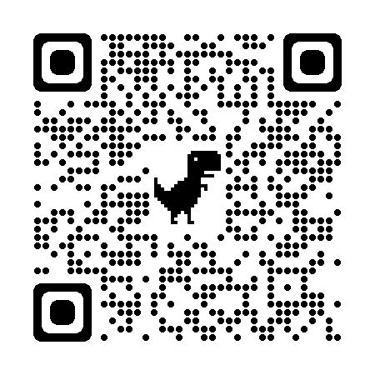
Special thanks to our funders who enable us to continue inspiring young people to build a confident future!
